**Report on Signaling pathways associated with inflammatory Bowel Disease**

**JAK-STAT Pathway**

* **Inflammatory Bowel Disease (IBD)** is set of **chronic**, **relapsing** and **remitting** inflammatory disorders. IBD is a combination of **two kinds** of **intestinal inflammation**: **Ulcerative Colitis** and **Crohn’s Disease**.
* The true origin of IBD is still unknown, but, the major culprits can be boiled down to **genetic susceptibility**, **immune imbalance**, **dysregulated host/microbial interaction**, and much more.
* IBDs have been confirmed to be **complex polygenic** and **multifactorial** diseases. Signaling pathways like **TLR**, **NF-κB**, **MAPK**, **JAK-STAT**, etc.
* First discovered in **1988** and **1992**, **STATs** and **JAKs** are proteins that led to the coining of the **JAK-STAT pathway**
* Pathway starts at the **cell membrane** with the activation of **membrane bound cytokine receptor** by an **interferon or an interleukin**
* Activated cytokine receptors then **recruit intracellular tyrosine kinases** of the JAK family (**JAK1, JAK2, JAK3 and TYK2**) to their cytoplasmic domains.
* After binding to this receptor, JAKs, **phosphorylate tyrosine residues** of the receptor
* **STATs** (named after their ability as **signal transducers and activators of transcription**) carry **SH2 domains** which allow them to **bind to the phosphorylated tyrosine residue.**
* Due to being in **close proximity to the JAKs**, the STATs also start to get phosphorylated. **Phosphorylated STAT** proteins **dissociate** from the receptor and **dimerize** via the SH2 domains
* These **Phosphorylated STATs** then **enter the nucleus** where they bind to specific **promoter motifs of the DNA** (Cytokine responsive elements [CREs])
* The DNA bound STATs **activate the transcription** of many target genes (**MYC and CCND2**)
* This pathway **mediates the signals of many different cytokines**.
* Specificity is achieved by the **specific combinations of JAKs** with **various STATs** which are able to **bind to different cytokine responsive elements.**

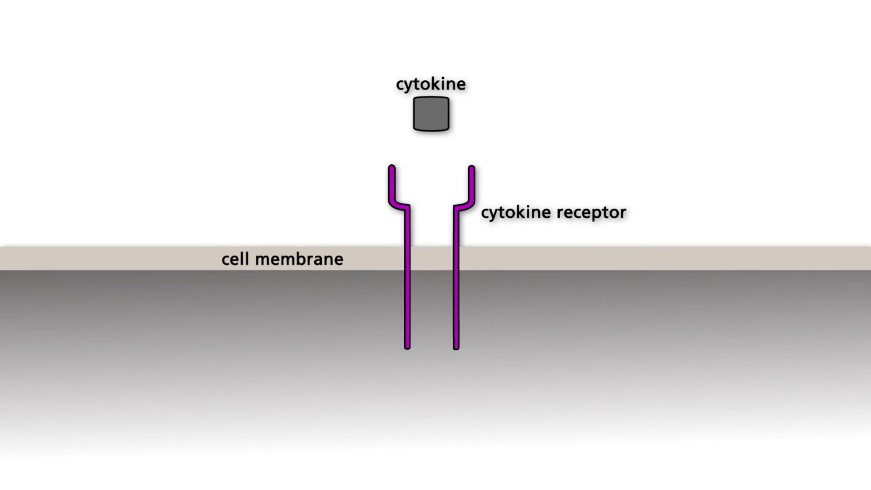Fig 1: Cytokine binding to Receptor

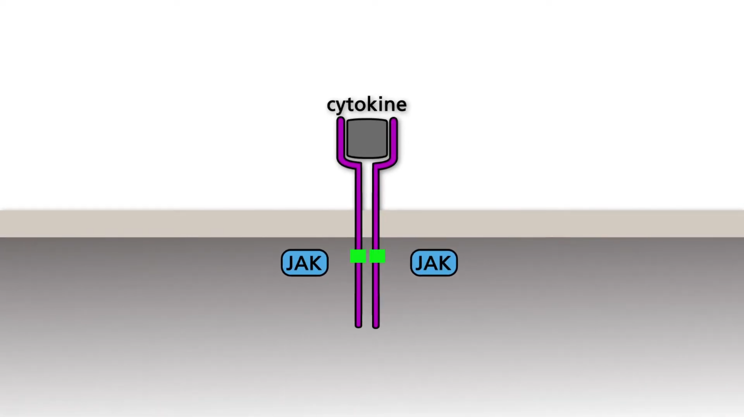Fig2: JAK binding to Cytokine Receptor

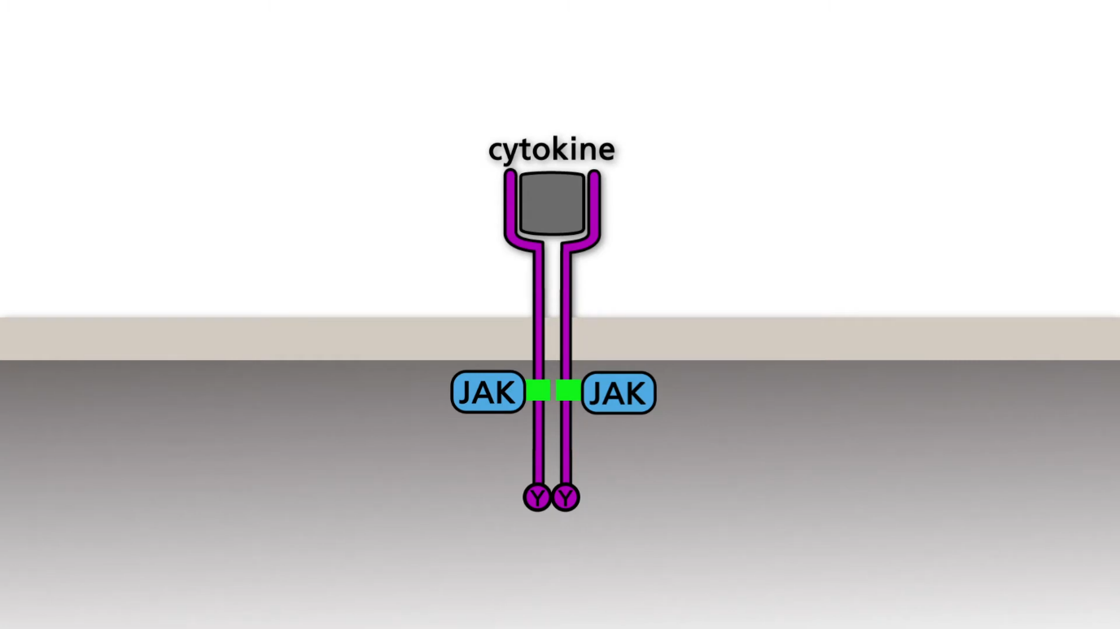Fig 3: Phosphorylation of Tyrosine residues on Receptor

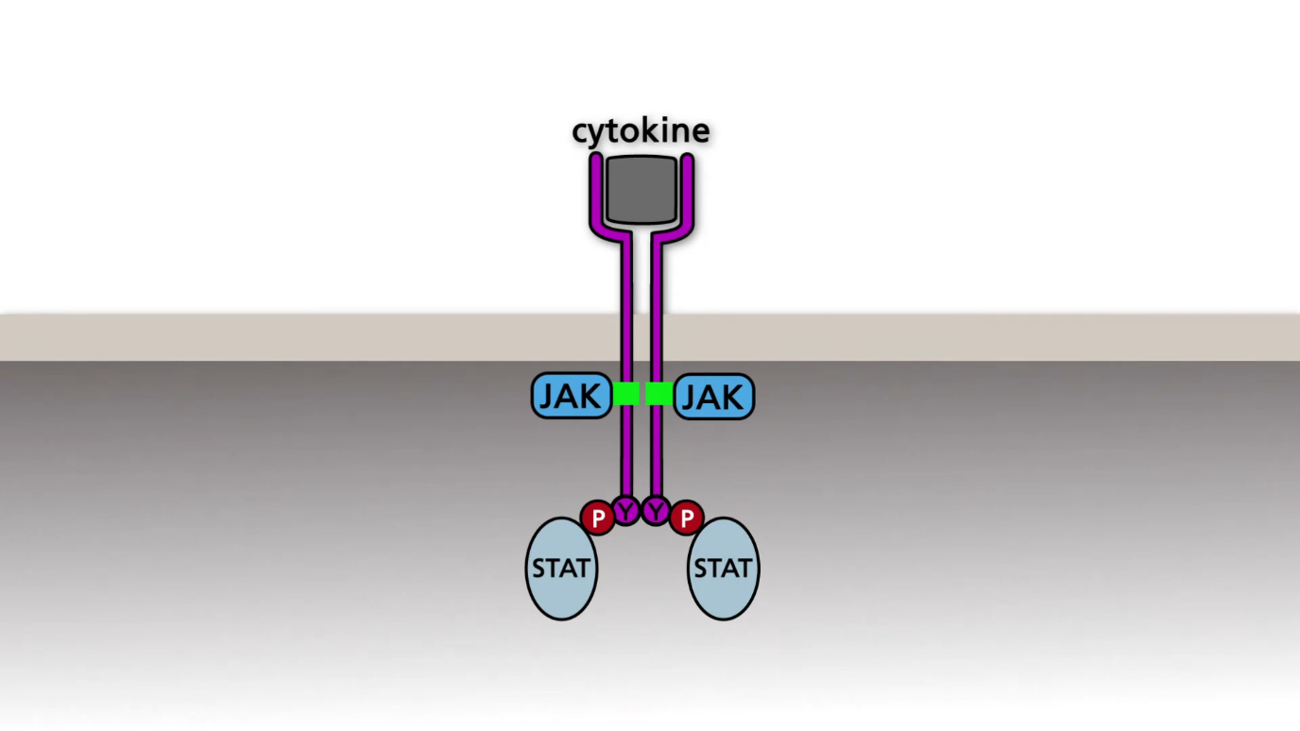Fig 4: Binding of STATs to phosphorylated Tyrosine Residues

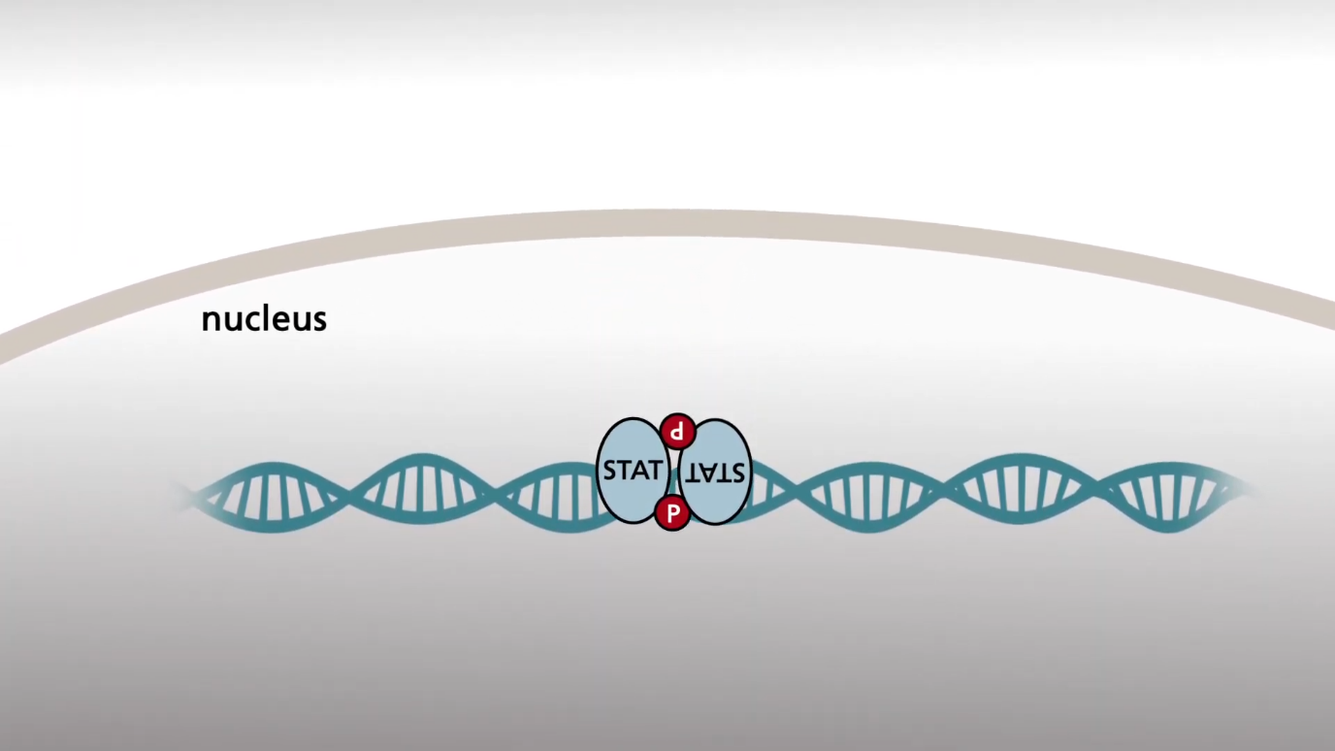Fig 5: Phosphorylated STATs entering Nucleus

REFERENCES

1. Wei, J., & Feng, J. (2010). Signaling Pathways Associated with Inflammatory Bowel Disease. *Recent Patents on Inflammation & Allergy Drug Discovery*, *4*(2), 105–117. <https://doi.org/10.2174/187221310791163071>
2. *The JAK/STAT pathway*. (2021, October 6). YouTube. <https://www.youtube.com/watch?v=qpnP8lSjxa0>